CalCOFI.io Docs
2024-09-10
Table of contents

1. Process
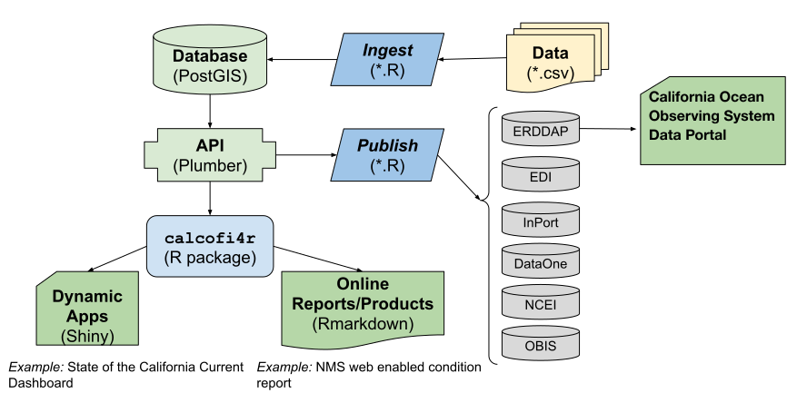
Figure 1.1: CalCOFI data workflow.
The original raw data, most often in tabular format [e.g., comma-separated value (*.csv)], gets ingested into the database by R scripts that use functions and lookup data tables in the R package calcofi4r where functions are organized into Read, Analyze and Visualize concepts. The application programming interface (API) provides a program-language-agnostic public interface for rendering subsets of data and custom visualizations given a set of documented input parameters for feeding interactive applications (Apps) using Shiny (or any other web application framework) and reports using Rmarkdown (or any other report templating framework). Finally, R scripts will publish metadata (as Ecological Metadata Language) and data packages (e.g., in Darwin format) for discovery on a variety of data portals oriented around slicing the tabular or gridded data (ERDDAP), biogeographic analysis (OBIS), long-term archive (DataOne, NCEI) or metadata discovery (InPort). The database will be spatially enabled by PostGIS for summarizing any and all data by Areas of Interest (AoIs), whether pre-defined (e.g., sanctuaries, MPAs, counties, etc.) or arbitrary new areas. (Figure 1.1)
- ERDDAP: great for gridded or tabular data, but does not aggregate on the server or clip to a specific area of interest

2. Reports

2.1 Sanctuaries
- Channel Islands WebCR
web-enabled Condition Report
  - Forage Fish
example of using calcofi4r functions that pull from the API
- UCSB Student Capstone

3. Applications
- CalCOFI Oceanography
oceanographic summarization by arbitrary area of interest and sampling period
- UCSB Student Capstone

4. API
The raw interface to the Application Programming Interface (API) is available at:
- api.calcofi.io
Here we will provide more guidance on how to use the API functions with documented input arguments, output results and examples of use.

4.1 /variables: get list of variables for timeseries
Get list of variables for use in /timeseries

4.2 /species_groups: get species groups for larvae
Not yet working. Get list of species groups for use with variables larvae_counts.count in /timeseries

4.3 /timeseries: get time series data

4.4 /cruises: get list of cruises
Get list of cruises with summary stats as CSV table for time (date_beg)

4.5 /raster: get raster map of variable
Get raster of variable

4.6 /cruise_lines: get station lines from cruises
Get station lines from cruises (with more than one cast)

4.7 /cruise_line_profile
Get profile at depths for given variable of casts along line of stations

5. Database

5.1 Database naming conventions
We’re circling the wagons to come up with the best conventions for naming. Here are some ideas:
- Learn SQL: Naming Conventions
- Best Practices for Database Naming Conventions - Drygast.NET

5.1.1 Name tables
- Table names are plural and use all lower case.

5.1.2 Name columns
- To name columns, use snake-case (i.e., lower-case with underscores) so as to prevent the need to quote SQL statements. (TIP: Use janitor::clean_names() to convert a table.)
- Unique identifiers are suffixed with:
  - *_id for unique integer keys;
  - *_key for unique string keys;
  - *_seq for auto-incrementing sequence integer keys.
- Suffix with units where applicable (e.g., *_m for meters, *_km for kilometers, degc for degrees Celsius). See units vignette.
- Set geometry column to geom (used by PostGIS spatial extension). If the table has multiple geometry columns, use geom for the default geometry column and geom_{type} for additional geometry columns (e.g., geom_point, geom_line, geom_polygon).

5.2 Describe tables and columns
- Use the COMMENT clause to add descriptions to tables and columns, either through the GUI pgadmin.calcofi.io (by right-clicking on the table or column and selecting Properties) or with SQL. For example:
- COMMENT ON TABLE public.aoi_fed_sanctuaries IS 'areas of interest (`aoi`) polygons for federal **National Marine Sanctuaries**; loaded by _workflow_ [load_sanctuaries](https://calcofi.io/workflows/load_sanctuaries.html)';
- Note the use of markdown for including links and formatting (e.g., bold, code, italics), such that the above SQL will render like so:
- areas of interest (aoi) polygons for federal National Marine Sanctuaries; loaded by workflow load_sanctuaries
- It is especially helpful to link to any workflows that are responsible for the ingesting or updating of the input data.
- These descriptions can be viewed in the CalCOFI API api.calcofi.io as CSV tables (see code in calcofi/api: plumber.R):
  - api.calcofi.io/db_tables
fields:
    - schema: (only “public” so far)
    - table_type: “table”, “view”, or “materialized view” (none yet)
    - table: name of table
    - table_description: description of table (possibly in markdown)
  - api.calcofi.io/db_columns
fields:
    - schema: (only “public” so far)
    - table_type: “table”, “view”, or “materialized view” (none yet)
    - table: name of table
    - column: name of column
    - column_type: data type of column
    - column_description: description of column (possibly in markdown)
- Fetch and display these descriptions into an interactive table with calcofi4r::cc_db_catalog().

5.3 Relationships between tables
- See calcofi/workflows: clean_db
- TODO: add calcofi/apps: db to show latest tables, columns and relationsips

5.4 Spatial Tips
- Use ST_Subdivide() when running spatial joins on large polygons.

6. References

6.1 R packages
- API: plumber (Schloerke and Allen 2024)
- docs: Quarto (Allaire and Dervieux 2024)
- apps: Shiny (Chang et al. 2024)
Allaire, JJ, and Christophe Dervieux. 2024. Quarto: R Interface to Quarto Markdown Publishing System. https://github.com/quarto-dev/quarto-r.
Chang, Winston, Joe Cheng, JJ Allaire, Carson Sievert, Barret Schloerke, Yihui Xie, Jeff Allen, Jonathan McPherson, Alan Dipert, and Barbara Borges. 2024. Shiny: Web Application Framework for r. https://shiny.posit.co/.
Schloerke, Barret, and Jeff Allen. 2024. Plumber: An API Generator for r. https://www.rplumber.io.

